**MIDDLETON CHENEY FOOTBALL CLUB**

**ANNUAL GENERAL MEETING**

**1966**

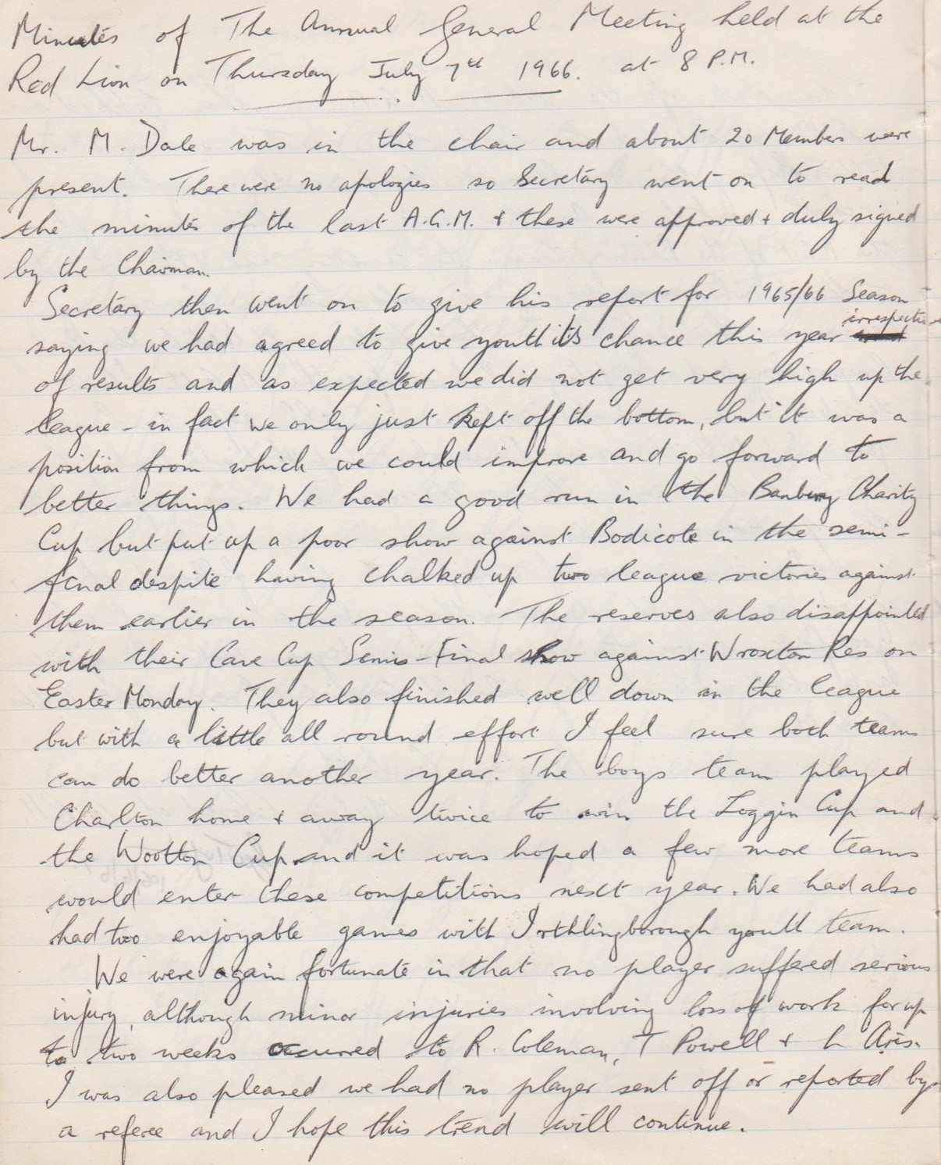

**Continued**



**Continued**

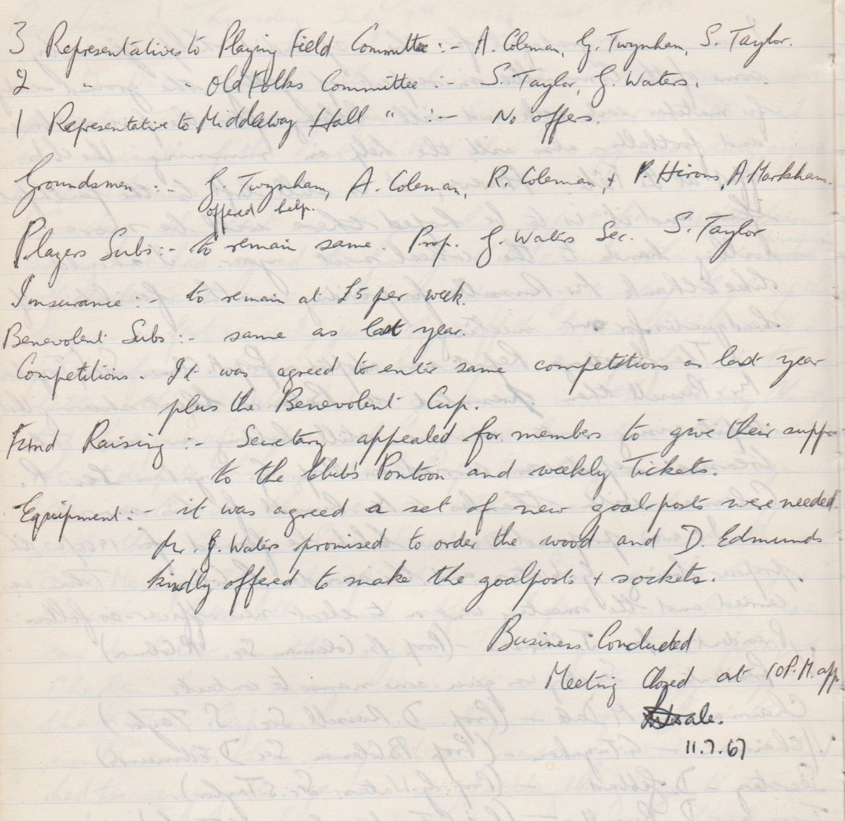

**Extraordinary Meeting**

**October 3rd 1966**

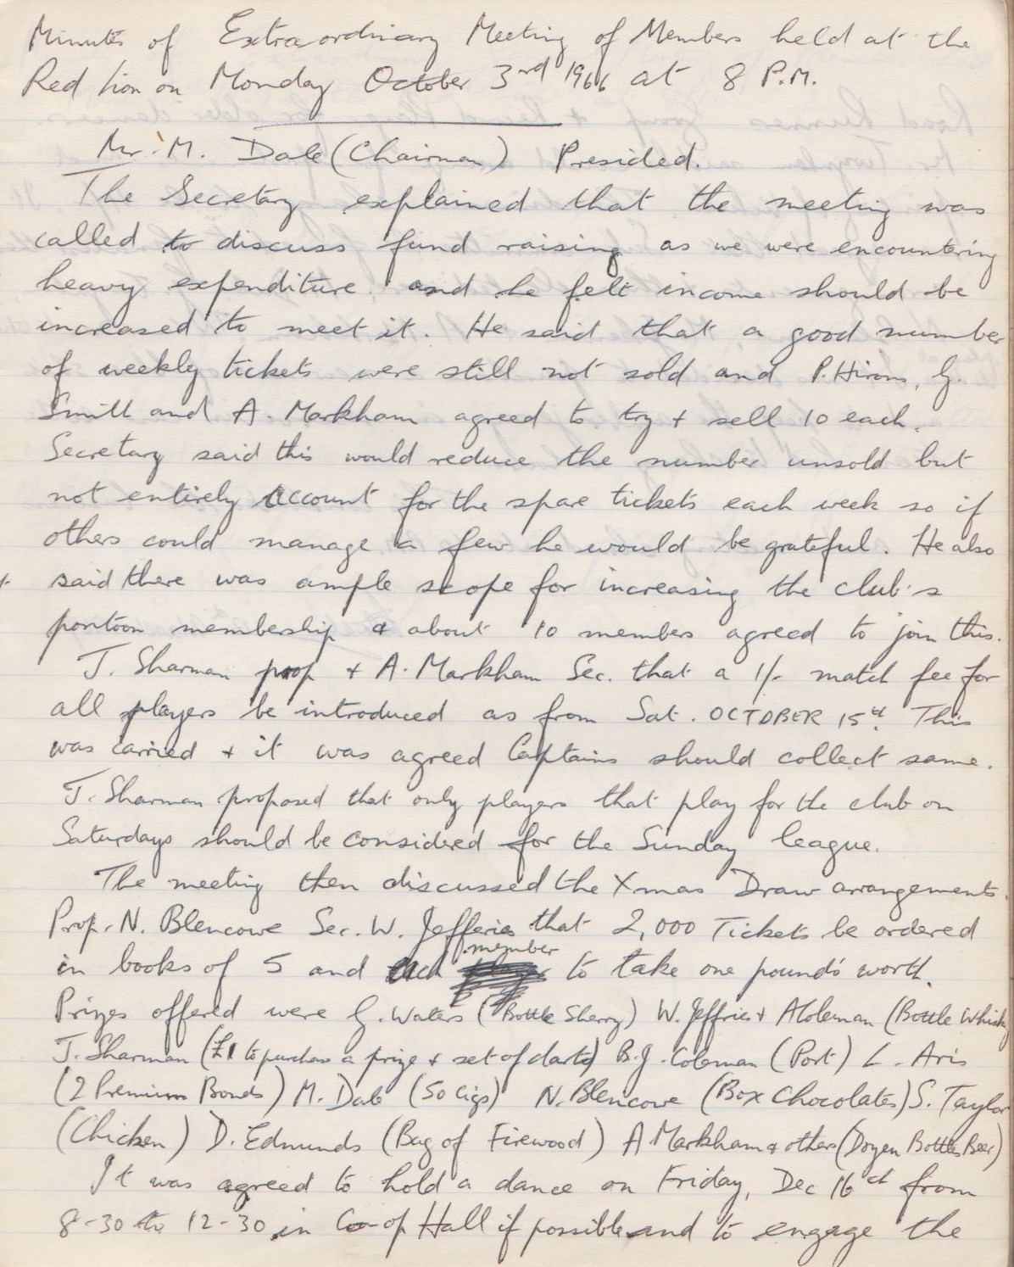

**Continued**

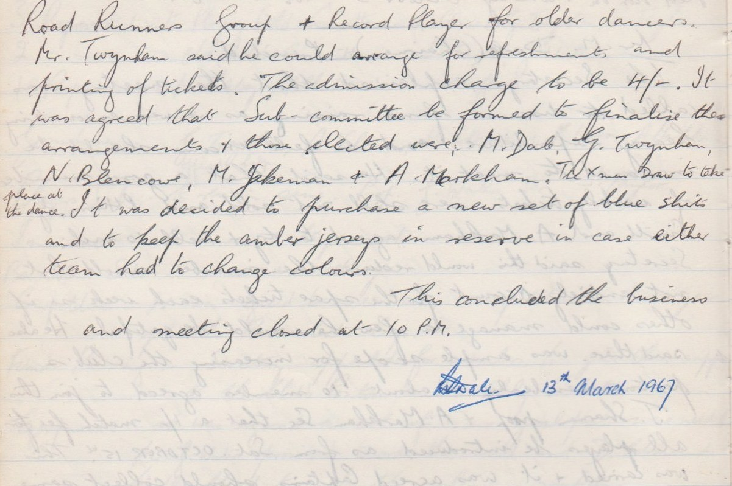

**Extraordinary General Meeting**

**March 13th  1967**

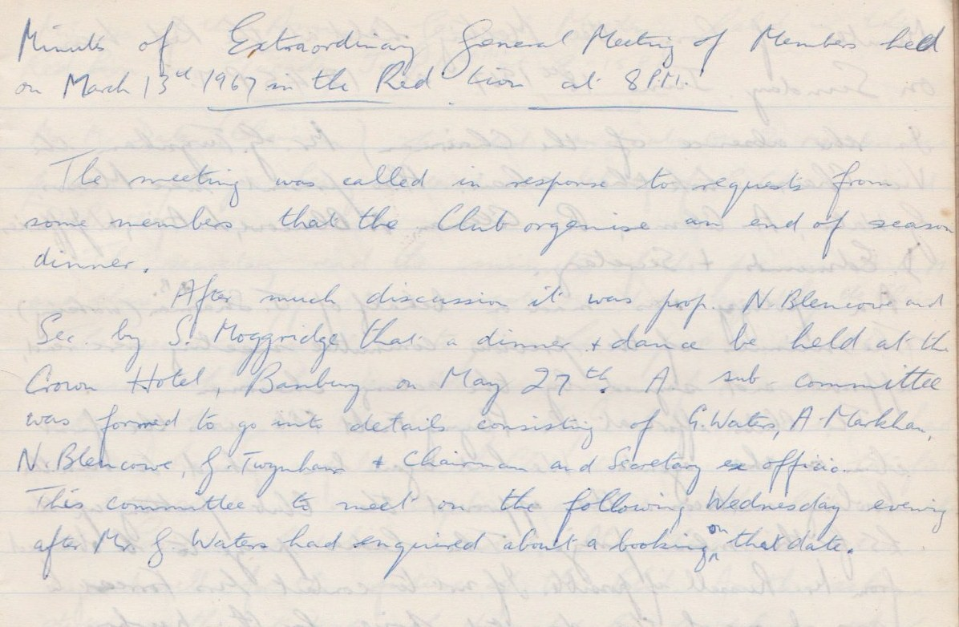

**Committee Meeting**

**June 18th 1967**

